Phase II: Org Setup and Configuration
Admission-Academic Journey Crm
Company profile setup
- Explanation: Configured the basic information for the educational institution to ensure that all systemgenerated data, such as addresses, currency, and time, is accurate and reflects the university's identity.
- Salesforce Path: Setup > Company Information
- Procedure: Updated the organization details to reflect the university's information, including its official name, address, and default localization settings.
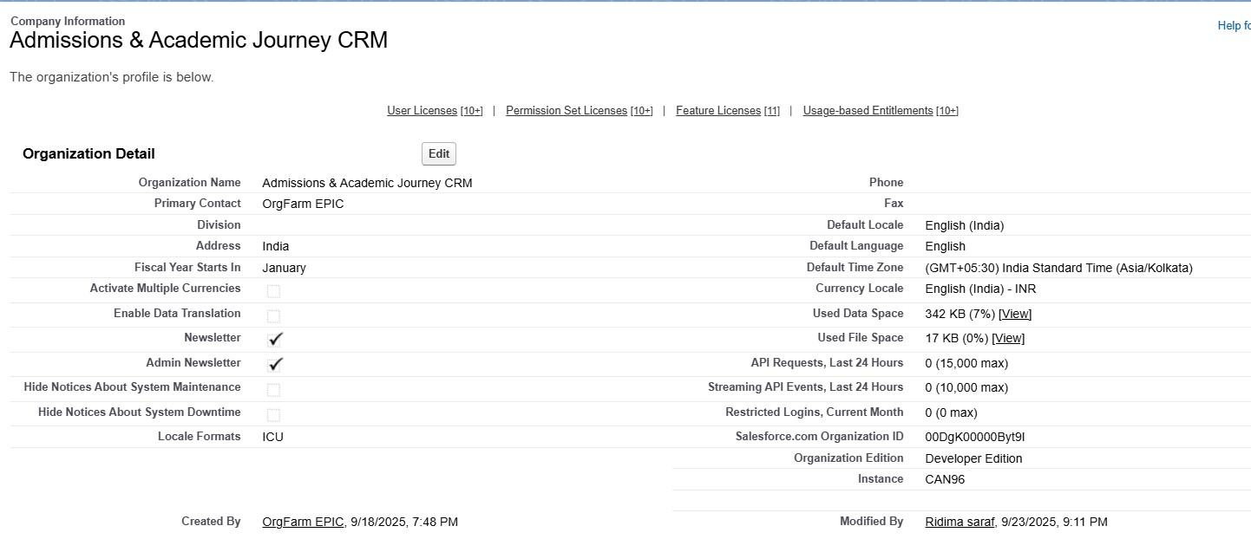
Business Hours & Holidays
Explanation: Defined the standard working hours for the admissions office and the official academic calendar holidays. This ensures that automated processes, such as applicant notifications and task reminders, only occur during operational periods.
Salesforce Path: Setup > Business Hours and Setup > Holidays Final Configuration:
- Business Hours: Mon-Fri, 9:00 AM - 5:00 PM
- Holidays: Specific dates added for academic semester breaks and festivals.
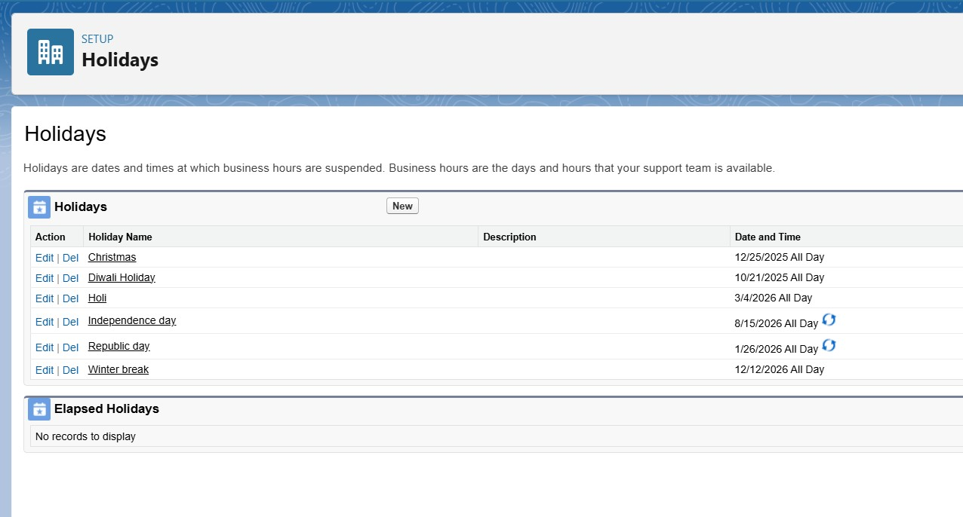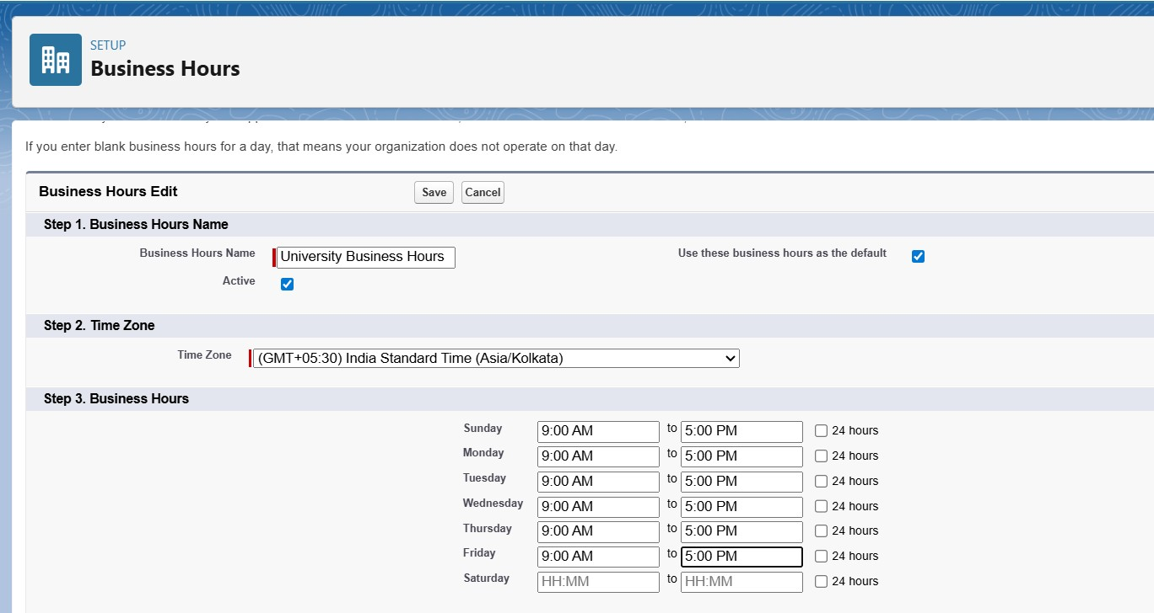

User Setup & Licenses

User Setup & Licenses
Explanation: Created user accounts for the key staff members who will manage the admissions process and track student academic progress, providing them with login access to the Salesforce org.

Salesforce Path: Setup > Quick search > user
Procedure: Created FIVE new user With appropriate salesforce licenses to represent Operational roles within the admission and academic department.
Final configuration:
- User 1: Aarav Sharma (Principal admin)
- User 2: Rohan Verma (Admission head)
- User 3: Rajesh Iyer (Department head)
- User 4: Pooja Nair (Mentor)
- User 5: Vikram Patel (counselor).
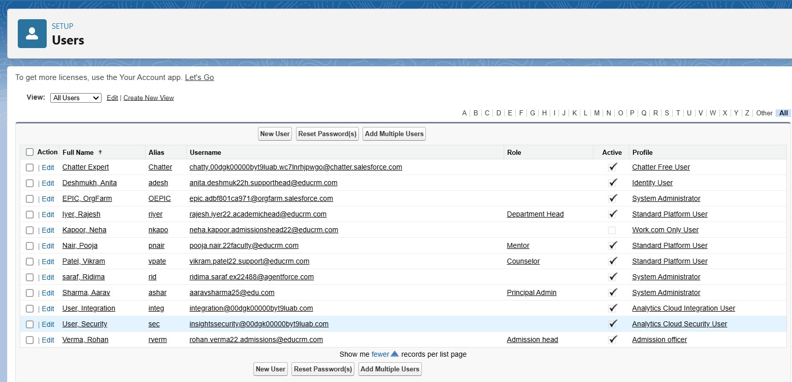

Profiles & Roles
Explanation: Defined user permissions and data visibility to protect sensitive student information. Profiles control what a user can do (e.g., edit an application), and Roles control what records they can see based on the organizational hierarchy.
Salesforce Path: Setup > Quick find >Profiles and roles. Procedure:
- Profiles: Cloned the Standard User profile to create custom profiles: Admissions head Profile, department head Profile, Counsellor, Mentor.
- Roles: Principal admin, Admission head, Departmental head( Councillor and mentor).

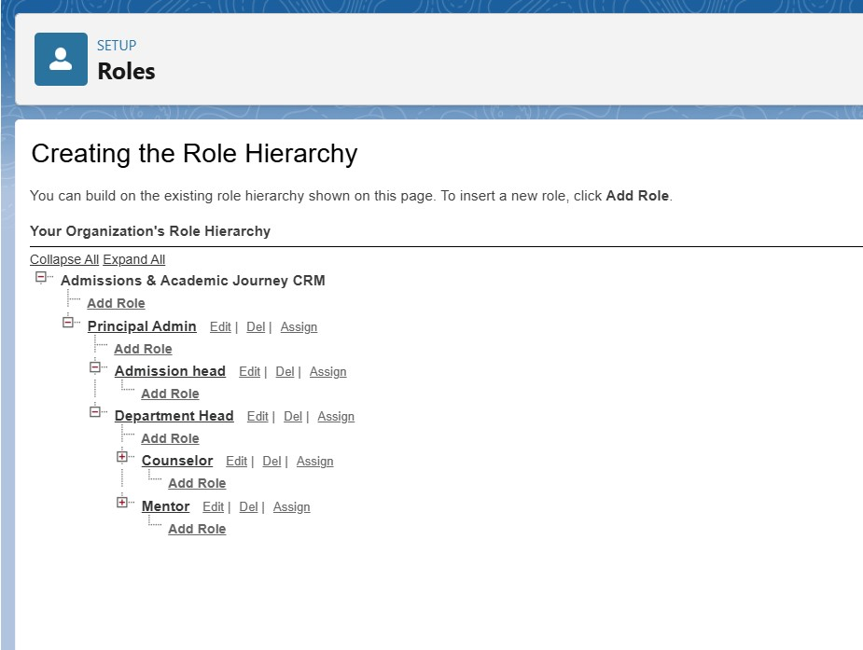

Organization-Wide Defaults (OWD) & Sharing Rules
Explanation: Set the baseline security for the org by making all student-related custom objects private to ensure data privacy and compliance. Sharing rules were then created as specific exceptions to this private setting to allow for necessary collaboration.
Salesforce Path: Setup > Quick find >Sharing Settings
OWD: Set the default internal access for the Academic record, Application, Student, Course, Counselling notes,
Department, Prospective Student Custom Objects to private.
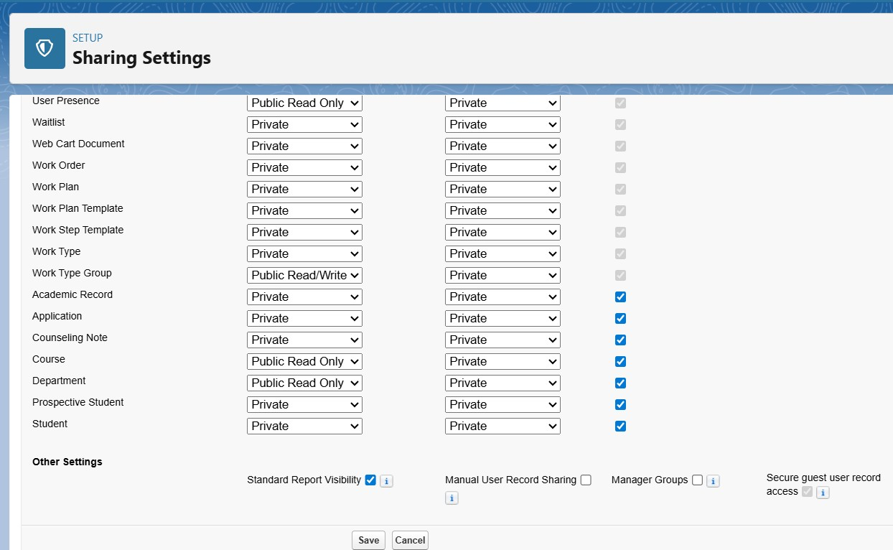
Clarification: In this CRM, Prospective Student represents applicants, while Student represents enrolled learners. Both objects are configured with private visibility to ensure data security.

Sharing Rules:
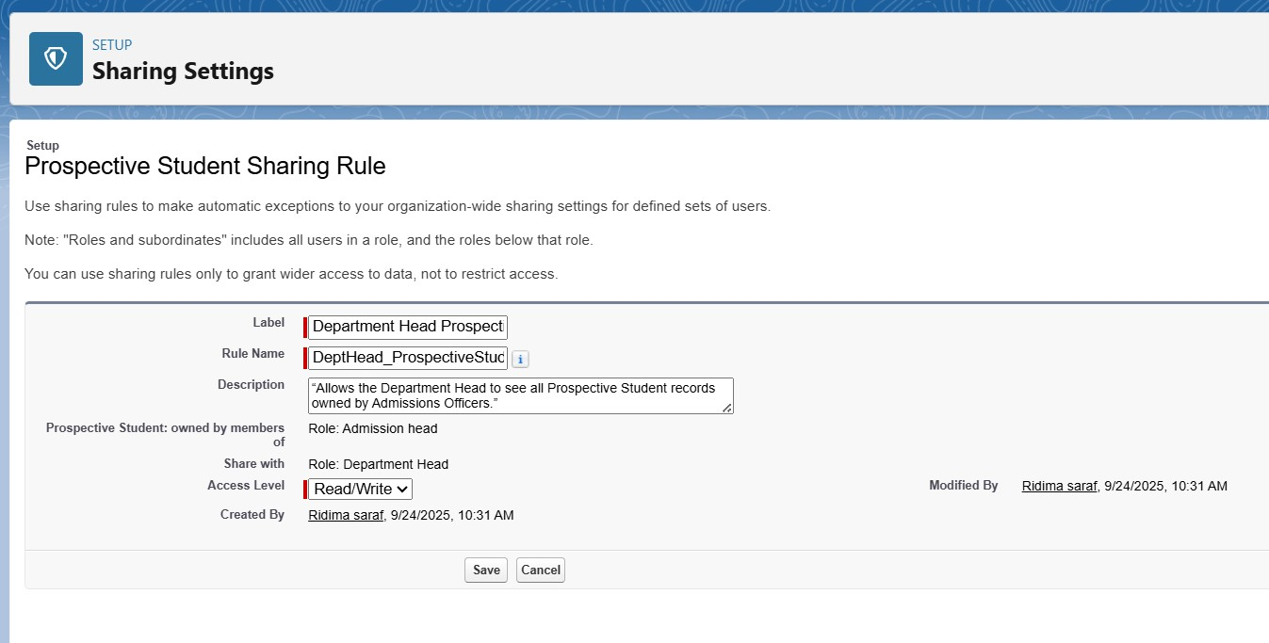

Dev Org Setup & Deployment Basics
Explanation: This served as a conceptual checkpoint. It confirmed that the Developer Org is the single environment for building and testing all configurations in this phase. No additional configuration for login policies or deployment is required at this stage.
Procedure: No action was needed as all necessary configurations were already performed in the previous steps.

